CartCo E-Commerce Checkout System: Architecture & STRIDE Threat Analysis
Prepared by: Reynan Cortado | BSIT-2 | SPELEC2D-11054
Reviewer: Security Engineering Team
Scope: Data Flow Diagram (DFD) Level 1 Analysis & Threat Assessment
System Architecture & Data Flow
- User Interaction Entry Point: The client interaction begins at the storefront user interface, where customers browse, manage cart items, and initiate the checkout process.
- Authentication Boundary: Identity verification is isolated at the perimeter. Session tokens and user credentials route through an External Authentication Provider to validate authorization prior to transaction execution.
- Core Application & Payment Processing: The central application tier manages server-side business logic, including order creation, price and tax calculations, and the secure handling of sensitive payment payloads.
- Backend Data Stores & Integrations: Data flows down to persistent storage systems and external connectors:
  - Database Services: Primary storage for customer accounts, real-time product inventory levels, and historical transaction logs.
  - Third-Party APIs: External integrations handling payment processing gateways and outbound logistics or fulfillment tracking services.
STRIDE Threat Assessment Focus
Given the monetary and PII exposure inherent to an e-commerce checkout pipeline, the threat model prioritizes critical transaction paths across three key STRIDE categories:
- Spoofing & Elevation of Privilege: Enforces strict boundary controls to block identity impersonation, secure administrative rights, and prevent unauthorized payment validation overrides.
- Tampering & Information Disclosure: Secures sensitive payment data, customer PII, and order details against unauthorized modification or interception using TLS 1.3 encryption in transit and database field-level encryption at rest.
- Denial of Service (DoS): Implements rate limiting and resilient scaling to guarantee high availability across critical API endpoints and payment gateways during peak shopping traffic.

CartCo E-Commerce Checkout System
DFD - Data Flow Diagram
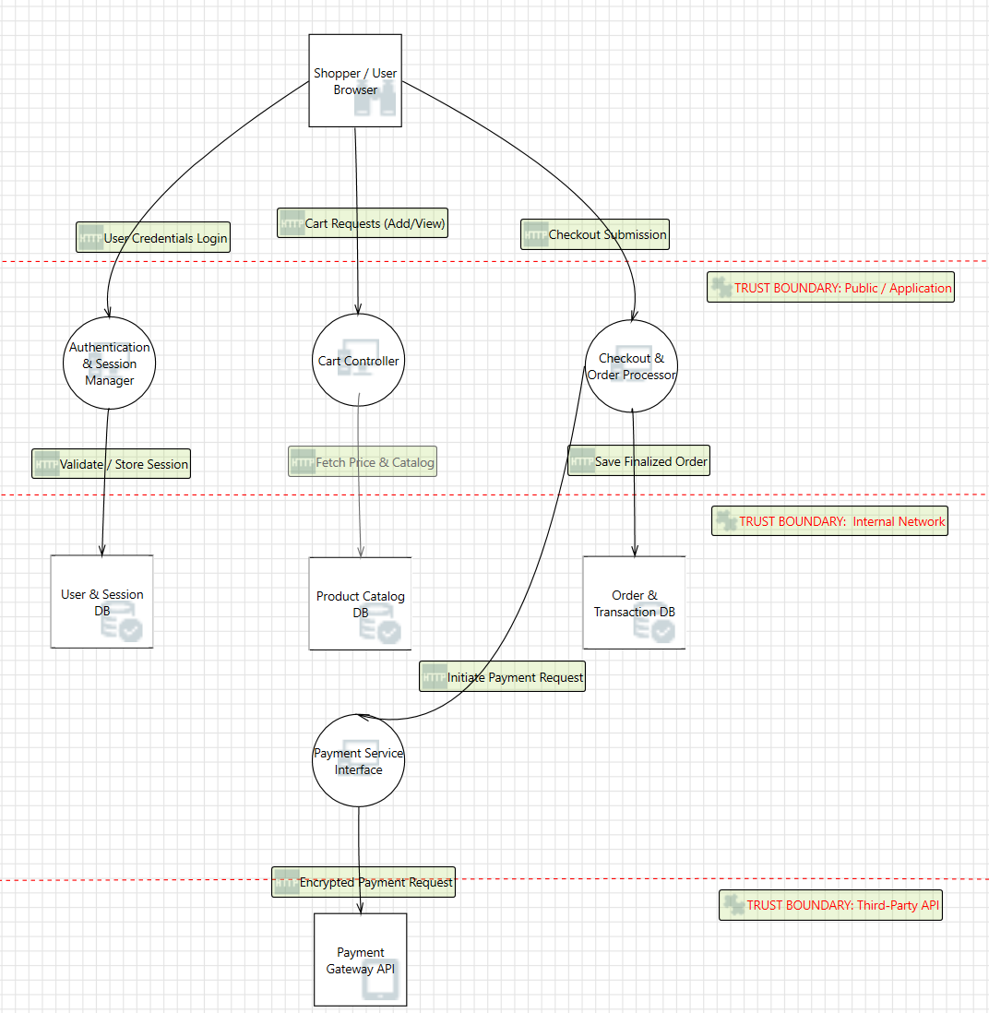

Analysis Tool & Threat List - Not yet mitigated just the list of generated threats from Microsoft Threat Modeling Tool.
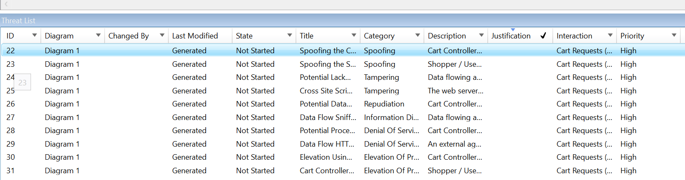

Before - Threat modeling reports show no data.
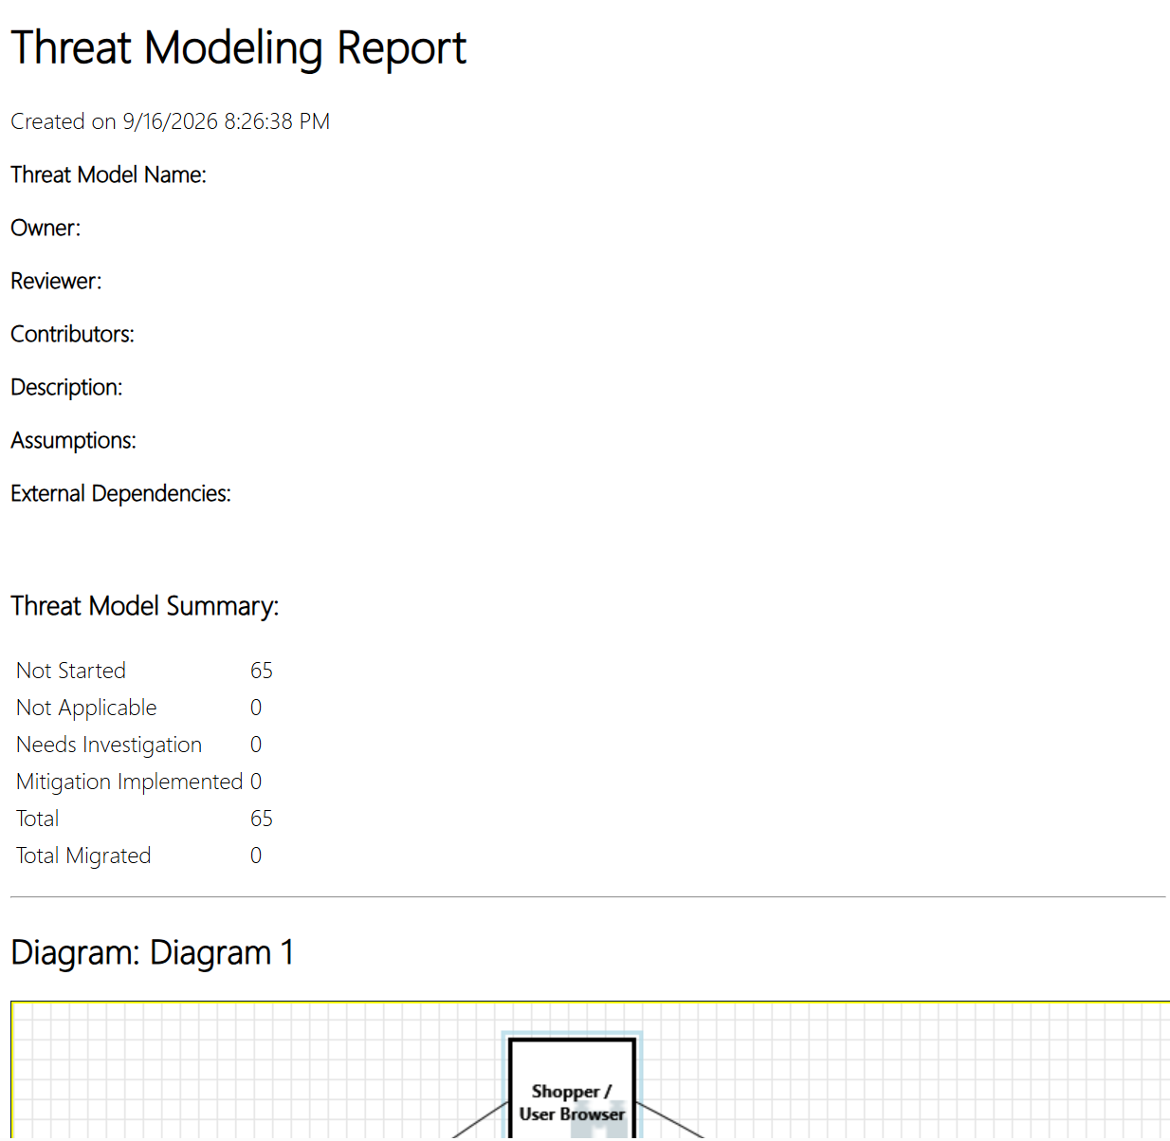

Threat Modeling Report
After - mitigation and justifications, downloaded from Microsoft Threat Modeling Tool via Report.
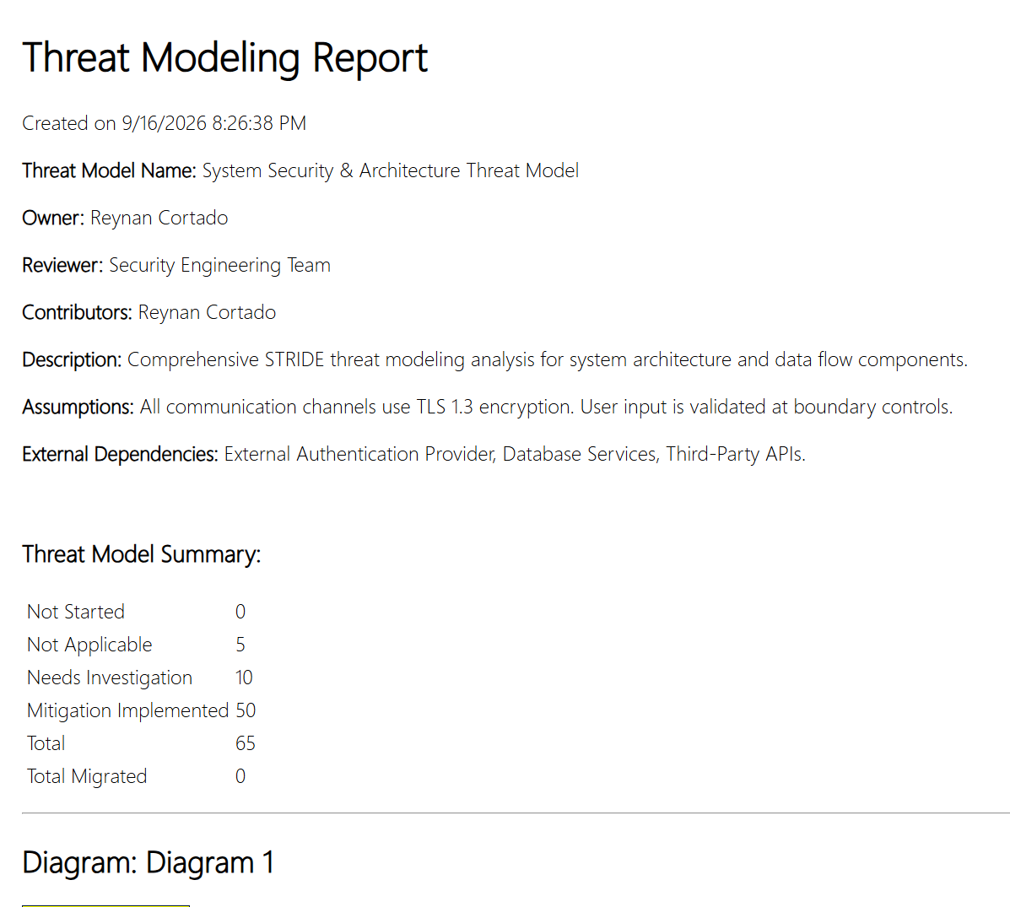

Executive Summary & Baseline Security
This report outlines the structural threat analysis conducted on the CartCo checkout infrastructure. The evaluation covers entry points, internal logic boundaries, data persistence tiers, and third-party communication channels using the STRIDE methodology.
Key System Assumptions
- Transport Encryption: All internal and external communication channels enforce TLS 1.3 encryption.
- Perimeter Validation: User inputs are sanitized and validated at boundary controls prior to application processing.
External Dependencies
- External Authentication Provider (OAuth 2.0 / Identity Provider)
- Centralized Database Services
- Third-Party Payment and Logistics APIs

Threat Model Quantitative Summary
Threat Status Category | Count | Status Description
Not Started | 0 | All identified threat vectors have been reviewed.
Not Applicable | 5 | Threats determined to be out of scope or controlled by host OS level.
Needs Investigation | 10 | Security findings currently undergoing deeper architecture review.
Mitigation Implemented | 50 | Verified security controls currently active in the system design.
Total Evaluated | 65 | Aggregate count of identified STRIDE threat scenarios.
Total Migrated | 0 | Baseline metric.

System Architecture & Data Flow Breakdown
1. User Interaction & Entry Points
- Storefront Interface: Primary entry point where users manage cart contents and initiate checkout workflows. Vulnerabilities here primarily involve cross-site scripting (XSS) and session hijacking.
2. Authentication & Authorization Boundaries
- External Auth Provider: User credentials and session tokens route through an external provider. Enforces identity verification prior to handling order execution.
3. Application Logic & Payment Core
- Central Processing Engine: Manages server-side calculations, order state creation, and sensitive payload handling. Protects against price tampering and unauthorized state alterations.
4. Data Persistence & Third-Party Integrations
- Database Services: Stores user profile data, real-time inventory records, and historical logs. Enforces field-level encryption at rest.
- Third-Party APIs: Outbound connections to payment gateways and shipping/logistics providers requiring strict payload verification and secure secret management.

STRIDE Category Focus & Security Mitigations
- Spoofing & Elevation of Privilege: Identity verification is isolated at the auth boundary to block credential theft, administrative rights escalation, and unauthorized payment approvals.
- Tampering & Information Disclosure: Data integrity for credit card payloads, order details, and customer PII is maintained using TLS 1.3 in transit and database encryption at rest.
- Denial of Service (DoS): Rate limiting, resource throttling, and resilient API scaling are configured to sustain high availability during peak traffic events.

Open Action Items (Needs Investigation Status)
The 10 open findings focus primarily on edge cases surrounding third-party API callbacks and database query optimization.
Next Steps & Recommendations
- Complete technical reviews for the 10 outstanding "Needs Investigation" items.
- Conduct automated SAST/DAST security pipeline tests against payment API endpoints.
- Finalize sign-off with the Security Engineering Team.

